VOC Report
November 2017 to April 2018
Background
Voice of Children is a new paradigm for children from an oppressed section of society. With the help of the Trans-Himalayan Aid Society (TRAS), Vancouver, BC, the children of Almora and Nainital district are transforming their lives with education. They are gradually connecting with the basic facilities such as Education Support Centers, Tuition classes, Computer Education, Special Coaching Education classes and Extra -curricular activities which were lacking earlier. This is the first half yearly report of Extension Project of VOC 2017-2020. These six months focused on establishment of coaching classes, resource centre for women and to improve education support centers, computer centers etc. During this interlude the following activities were carried out.
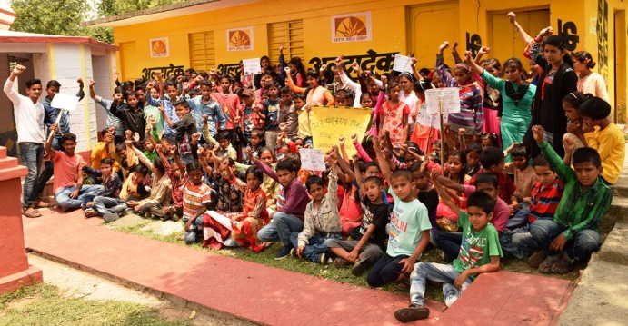
Education Support Centers for Children
Every child has the right to adequate care, learning, development and protection but the children from low income families face difficult situations. Poverty influences a child’s education attainment. Generally, in villages, children are providing a helping hand in domestic and agriculture work, they have no time for studies and their parents are not aware of the value of education. As a result they are not able to perform well in comparison to other children and feel detached from school.
Education Support Centers provide education to children belonging to poor and deprived families and also motivate and connect the children to Government schools. Different extracurricular activities of the centers play an instrumental role in the development of the child. During this period, 178 children (79 male and 99 female) were enrolled in 5 Education Support Centers in the villages of Rarkhila, Pathura, Gallibasura, Silani and Dangikhola. Education Facilitators/Teachers impart the subject base education among children. The creative activities like drawing, crafts, group reading and games have increased the learning level. Village details of Education Support Centers for Children are below
SN | Village | Total Children Enrolled in the Education Centers | Male | Female | Name of Facilitator
1 | Rarkhila | 28 | 11 | 17 | Rajni
2 | Pathura | 49 | 24 | 25 | Pooja
3 | Galli Basura | 30 | 15 | 15 | Pinky
4 | Silani | 29 | 11 | 18 | Sunita
5 | Dangikhola | 42 | 18 | 24 | Meenakshi
 | Total | 178 | 79 | 99

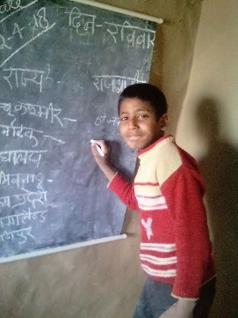
Tuition Classes
To make education available to the needy section of the community, tuition classes are conducted. These classes are focusing on enhancing the child’s ability to develop and enrich their potential and skills. Local facilitators/teachers developed a curriculum that includes subject knowledge, general knowledge, environment and health related information. 114 children (55 male, 59 female) are associated with the Tuition Classes.
SN | Village | Total Children Enrolled in the Tuition Classes | Male | Female | Name of Facilitator
1 | Jinouli | 28 | 17 | 11 | Munni
2 | Tari | 25 | 10 | 15 | Anand Ballabh
3 | Pangkatara | 9 | 4 | 5 | Preeti Joshi
4 | Simalkha | 24 | 11 | 13 | Radha Devi
5 | Gailek | 28 | 13 | 15 | Deep
 | Total | 114 | 55 | 59

The center facilitators are dedicated to help the children. They are teaching children according to their syllabus which is helping retaining them in schools. They keep the students motivated and interested and ensure that the topics are taught using different activities and learning games.
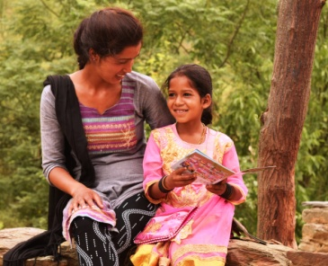
The team of the VOC is strengthening education for 292 Children (134 male and 158 female).
Priyanka is a 9-year girl studying in 4th class at the Rarkhila Primary School. In 2017 she joined the Education Support Center, at that time she didn’t speak a lot, was very weak in studies and didn’t even know how to read or write. She was very shy and rarely interacted with other children, and she was not able to respond to teachers. One year later, Prinyanka showed many behavioral changes. Now she has started to learn and plays and talks with other children. Gradually she has tried to read and write Hindi sentences. Her confidence has also increased. She comes daily to the education center and tries to interact with everything. She also tries to connect more with the children studying in the center. Painting, drawing and reading are her hobbies. Due to the initiatives of the center’s Facilitators they were able to find her inner strength and discovered the real her.
Resource Centers for Children and Women
Special Coaching Education Center
AMAN started the Special Coaching Centers for Children, March 2018 in Govinpur. It is the center for the VOC Project. 29 children in classes 9-12, from 9 villages (Galli basura, Silani, Rarkhila, Pathura, Odla, Rikhe, Daulaghat and Chinona) are regularly attending the Special Coaching Education. In the Hawalbagh block, the coaching center is run by Mrs. Kavita Tewari, who studied Science and has a two-year diploma in Pharmacy. Since April, 2018 the Coaching Education Center runs daily. In the summer season the school sessions are 7:00 am to 1:00 pm and the education center runs from 2:00 pm to 4:00 pm. It was decided that in winter season the special coaching education centers will be run weekly or during the school vacation time. Regular coaching is provided for Math, Science and English.
VIMARSH is in the selection process and will be starting their Coaching Education Centre soon.

Women Counseling and Resource Center
Both organizations started a Women Counseling and Resource Center. AMAN had organized a meeting for disseminating the information on the Women Counseling and Resource Centre. In this meeting, the senior judge of the Civil Division and the secretary of the DLSA (District Legal Cell Authority) were invited. AMAN connected the 161 women to DLSA. DLSA also pursued 5 domestic violence, widow and disabled pension cases. The main purpose of the Women Center is protecting women from violence and provides legal advice. The Centre also gives education, career and health counseling. VIMARSH also started this centre in their field area. Both organizations appointed a part time field worker for counseling and advice. During this period, the formats of different government schemes were collected by field workers and they started to give the information about it.
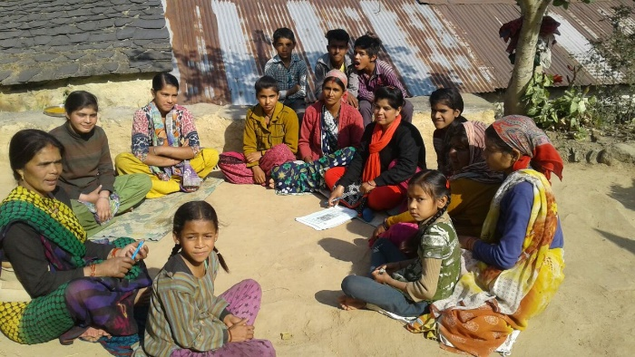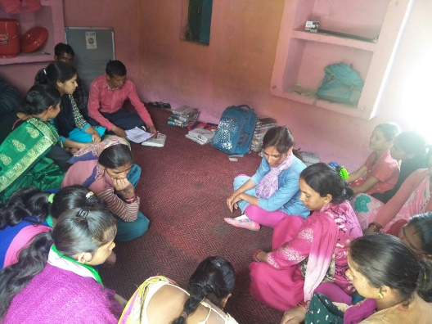
As a result, 10 families were connected with the Prime Minister Ujjwala Scheme. Prime Minister Ujjwala Yojana is a scheme of the Ministry of Petroleum & Natural Gas for providing LPG connections to women from Below Poverty Line.
This measure will empower women and protect their health. It will reduce drudgery and the time spent on cooking.
Two families started the Certificate of Marriage registration. A Certificate of Marriage is a document that provides valuable evidence of marriage. It is also providing social security and self-confidence particularly among married women. 50 children received the Domicile Certificate and the Caste Certificate. The Domicile Certificate establishes the place of residence of an individual. A number of educational institutions reserve seats depending on the domicile status of the applicant. Similarly, benefits are also available in a number of recruitment cases in giving preference to local candidates. This certificate is needed to avail such benefits and may also be required by institutions giving loans as a proof of place of residence. The Caste Certificate also gives the benefits to Dalit Families.

Computer Literacy Program
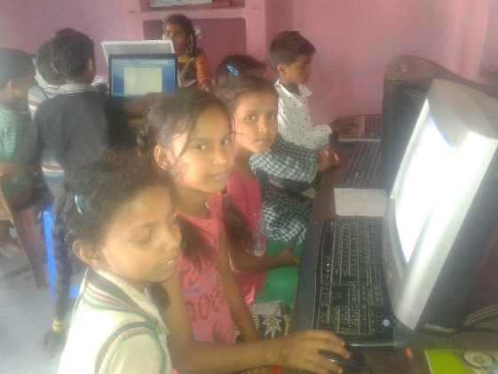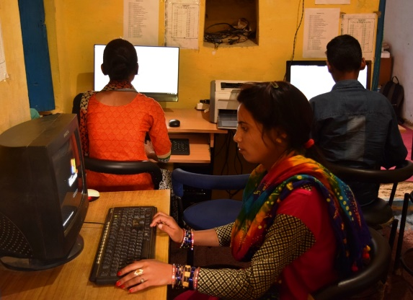
In both areas, the Computer Literacy centers are running smoothly. 32 children from Nainital and 27 children from Almora have benefited. 4 women (1 in Nainital and 3 in Almora) are also registered. They are coming daily to learn computer skills. MS office, Hindi and English typing and using the internet are the main focus during this period.
Fellowship Program
46 children (32 female and 14 male) who belong to a poor and deprived section of society are supported through the Fellowship Program. To retain the children in school and to reduce the dropout rate, 10 children were identified in the Nainital District and 36 children were identified in the Almora District for the Fellowship Program. The Fellowship Program provides school bags, note books, syllabus books and shoes.
SN | Children Name | Gender | Village | Class
1 | Laxmi Arya | F | Rarkhila | 5
2 | Payal Arya | F | Rarkhila | 8
3 | Rahul | M | Rarkhila | 10
4 | Pinky | F | Rarkhila | 10
5 | Sunil kumar | M | Dangikhola | 8
6 | Kareena Arya | F | Dangikhola | 9
7 | Arti Ghariyal | F | Dangikhola | 10
8 | Mohit Dangi | M | Dangikhola | 9
9 | Babli Arya | F | Dangikhola | 10
10 | Sunita Ghariyal | F | Dangikhola | 7
11 | Bhumika Arya | F | Dangikhola | 6
12 | Arti Dangi | F | Dangikhola | 12
13 | Raghu Dangi | M |  | 9
14 | Jaya | F | Galli Basura | 10
15 | Gourv Kumar | M | Galli Basura | 9
16 | Yogesh Kumar | M | Galli Basura | 9
17 | Shakshi Arya | F | Galli Basura | 9
18 | Siya Arya | F | Galli Basura | 6
19 | Pooja Arya | F | Galli Basura | 6
20 | Vinod Kumar | M | Galli Basura | 9
21 | Bhawna Arya | F | Galli Basura | 12
22 | Payal Arya | F | Galli Basura | 7
23 | Neetu | F | Galli Basura | 6
24 | Sunil Arya | M | Gailek | 3
25 | Deepa Arya | F | Gailek | 10
26 | Mohit | M | Silani | 12
27 | Vijay Bisht | M | Silani | 4
28 | Anil kumar | M | Silani | 10
29 | Bhawna Arya | F | Silani | 12
30 | Suraj Kumar | M | Pathura | 12
31 | Ashish Kandpal | M | Pathura | 9
32 | Pooja Arya | F | Pathura | 10
33 | Manisha Arya | F | Pathura | 8
34 | Pradeep Bhandari | M | Bajgal | 9
35 | Shivani Bhandari | F | Bajgal | 9
36 | Shakshi Arya | F | Govindpur | 12

SN | Name of the student | Name of the village | Class
1 | Komal | Jinouli | 8
2 | Meenakshi | Jinouli | 7
3 | Yamini | Jinouli | 4
4 | Himani | Pangkatara | 7
5 | Babita Arya | Tari | 6
6 | Anita | Tari | 9
7 | Yachika | Jinouli | 2
8 | Mamta | Pangkatara | 7
9 | Neema | Tari | 9
10 | Aishwarya | Tari | 4
VIMARSH also provided fellowship to 10 girls and have provided them all note books. The decision was also made that the girls who are being provided with a fellowship will be further be helped to complete the examination form.

Capacity building of Volunteers and Project Staff
Regular meeting with staff and volunteers is conducted monthly in both areas. Reporting and monthly planning has executed during the staff meetings. Bal Mela- scheduled in June, 2018
Community Mobilization-
Regular Meeting with BAL Santhan- (Children’s Group)
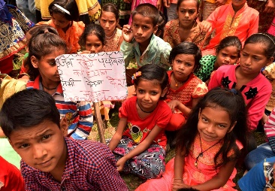
Regular meetings were organized with the children groups in both areas. AMAN organized 31 meetings and VIMARSH organized 27 meetings with various issues such as child rights, gender discrimination, personal hygiene, protection of children, right to education, child labor and help line, environmental rights, republic day, red hand day and a sustainable development goal etc. More than 400 children participated in these programs.
Regular meeting with Mahila Sangthan
Regular meetings were organized with the women’s groups in both districts. A total of 84 meetings (47 were organized by AMAN and 34 meetings were organized by VIMARSH) were conducted. Monthly meetings focused on gender, PCPNDT, local self governance, domestic violence, right to education, International Women’s Day, government schemes related to women and children, rural-library and sharing of water testing report etc. More than 500 women in both areas participated in these meetings.
Collective Meetings
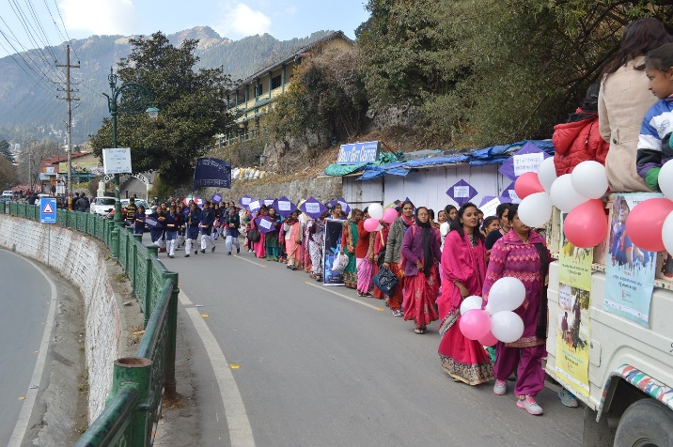
Both organizations also organized a cluster meeting of the women and children groups for sharing their experiences and to unite on the issues. International Women’s Day was celebrated in both areas with enthusiasm. AMAN also organized a training program on fruit processing for the women’s groups and VIMARSH organized a One billion rising campaign. More than 500 women connected with these programs.

